Valnes WebLock user manual

WebLock enables users to provision access rights over the net.
Note! User must enter the code followed by „#“! Example: if code is 1234 then at the key pad, user must type „1234“ + „#“.

General logic
For person to get an access right for a door, they need to have cards and they need to belong to a group which has access to device.
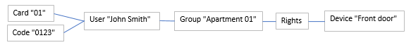
Picture 1. General logic
Process:
- Create a group:
  - Click „Groups“ from main menu;
  - Click „Add new group“;
  - Type the name of the group;
  - Don’t forget to click save!
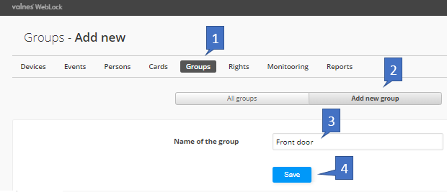
Picture 2. Creating a group
- Add a person:
  - Select „Persons“ from main menu;
  - Click on „Add new person“;
  - Input data. Only required field is „Forename“. All others are optional;
  - Don’t forget to click „Save“.
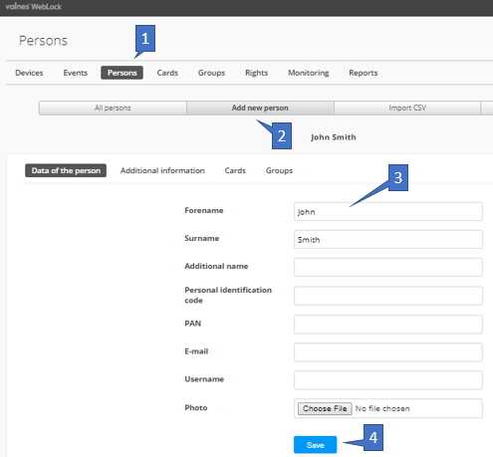
Picture 3. Adding a person

- Adding a person to a group:
  - Click on the person’s name (Picture 3);
  - Navigate to groups (Picture 4, pt. 1);
  - Select a group;
  - Specify dates if needed to restrict;
  - Click „Add to the group“ to confirm.

Picture 4. List of persons

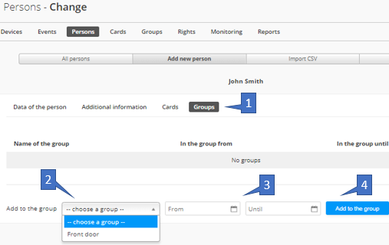
Picture 5. Adding a person to a group
- Create an access right:
  - From main menu select „Rights“;
  - Select „Add new rule“ from sub menu;
  - Select a device/door;
  - Select a group who will be accessing that device. A group can have several rights for several devices;
  - Select weekdays when the access right is given;
  - Choose the dates when you want the right to be active. You can also specify times at when the rule is active during the day;
  - Don’t forget to click „Save“.
Ps. If you want to temporarily deactivate an access right, you can change „Active“ to „no“.
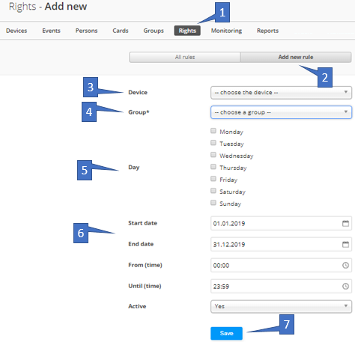
Picture 6. Rights section

- Add a card or code to person:
  - From main menu click „Cards“;
  - From sub menu click „Add new card“;
  - When you’re provisioning a PIN code, select „Card type“ PIN code. In case of key card, choose type „Key card“. When PIN code is selected, system automatically generates 6 digit PIN code. Please refrain from using PIN codes like „0000“ or „1234“;
  - Selecting dates allows you restrict when codes/cards can be used for access;
  - Don’t forget to click „Save“.
When you followed steps 1-6, you have granted access to a person!
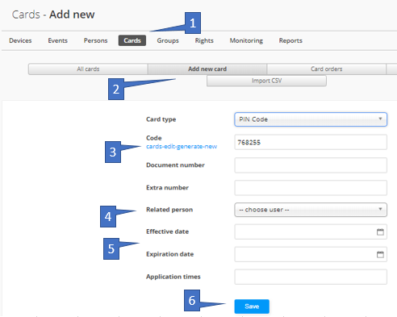
Picture 7. Adding a card/PIN code
- Opening a door under „Devices“:
  - Select „Devices“ from main menu;
  - Click on red or green button to open the door on-demand.
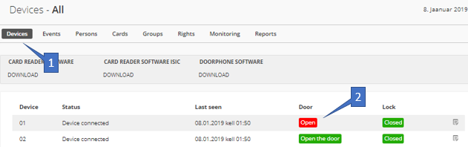
Picture 8. Devices section
- Users can see events log in „Events“ section.

